Reading Nutrition Fact Labels
Post-Lab Activity 2 - Teacher Guide
Grades 2nd & 3rd

Overview
This activity provides an overview on how to read and interpret Nutrition Fact labels.

Materials
- For the first part of this activity we suggest you divide your class into small groups of 3 to 4 students per group.
  - Each group will need one package of food with a nutrition fact label (your choice)
- 2 talking items per student (i.e. unifix cube, base 10 block, coin, counter, etc.)
- Kitchen Science Fun Instructional Video 3 (located on our website)
- Video viewing equipment
- Nutrition labels (pages 3 – 7)
- Additional supplies may vary depending on which activity you choose to complete (see procedures)

Getting Ready
Read this lesson plan thoroughly to determine which activities you are going to choose to complete. You will need to gather a variety of food items (with a nutrition fact label) to bring into the class depending on how many groups you wish to create in your class.

Procedure
Divide students into groups (with 3 to 4 students per group). Give each group a package of food of your choice (i.e. potato chip bag, cookies, anything with a detailed nutrition fact label). Have the students examine the food item (especially the label) as a group.

Give each student two talking items (any object they can place in the center of the group to designate they have spoken two times – i.e. unifix cube, base 10 block, coin, counter, etc.). With the first talking item the student must state something they observed about the nutrition fact label. With the second talking item the student must state something they question about the nutrition fact label (something they don’t understand, something they’ve always wondered about, what is healthy vs. non-healthy, etc.). Students take turn sharing their statement/question and placing their item in the middle of the group designating that they have spoken. The purpose of this opening activity is to give everyone a voice and encourage equal participation in the group. At the end of the talking activity all talking items should be placed in the middle of the circle.

View the Kitchen Science Fun Instructional Video 3 focused on how to read a nutrition fact label.

Have the students practice reading labels using the attached examples using any way you wish. Listed below are some possible ideas on how to use the examples.

**Note to teacher - some of the examples are more challenging than others. Please review the example before assigning it to a group. **

- Assign one label to each group. Have them analyze the entire nutrition fact label. Then present their findings to the class.
- Create posters around the room. Have students stop at each poster and record a fact about the label (find something new to say about the nutrition fact than already recorded on the poster).
- Create stations within the room/group. Have all students look at all examples and answer specific questions (see question suggestions below each example).
- Give each group of students two different labels. Have students draw two interlocking circles (Venn Diagram) on a piece of notebook paper. Have them compare/contrast the two labels. They can decide which food item would be the healthier snack (based upon calories, sugars, etc.).
- Use the food items you brought into class (see first step in the lesson plan). Have the students complete one of the above ideas with the food package.

Explanation
The goal of this lesson is to make students aware of nutrition fact labels. Many people do not realize the “servings per container” line when looking at the nutrition fact label. Hopefully students can become aware of the reality of healthy vs. non-healthy choices while walking through the grocery store with their parents.

Assessment
Depending on which lesson idea you use the assessment tool may vary. Students can be evaluated with a teacher created rubric if a presentation or poster was created. Students can also use the provided questions/answers to be evaluated on accuracy of reading the nutrition fact label. Feel free to cut off/cover up the questions and answers section on the page for student use.

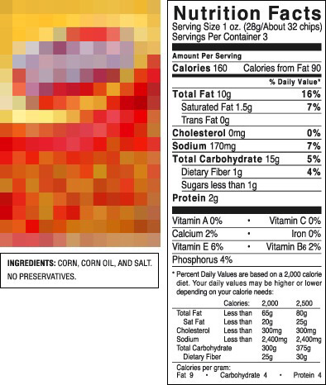
Questions
- How much protein is in the whole bag?
- How much total fat is in the whole bag?

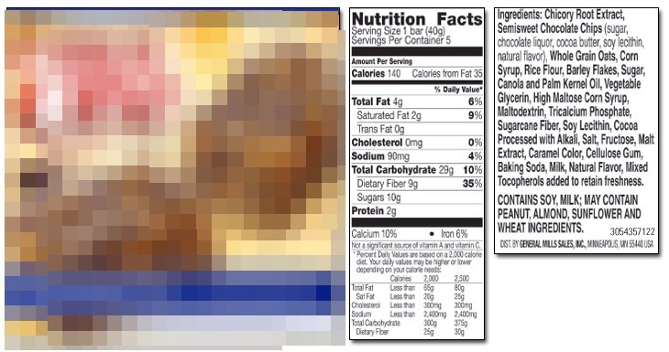
Questions
- If I ate the entire box of bars (all 5 bars) how many grams of sugar would I consume?
- How many grams of protein would I consume if I ate 2 bars?

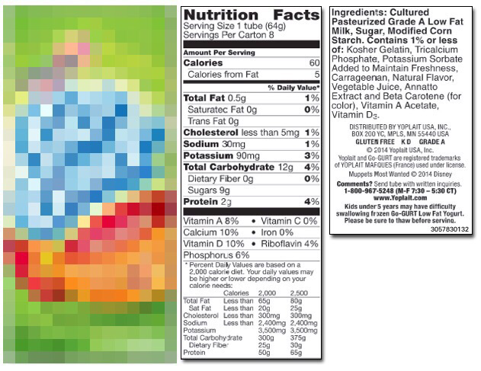

Questions
- If I ate the entire box (all 8 tubes) how many grams of sugar would I consume?

- How many calories would I consume if I ate 2 tubes?

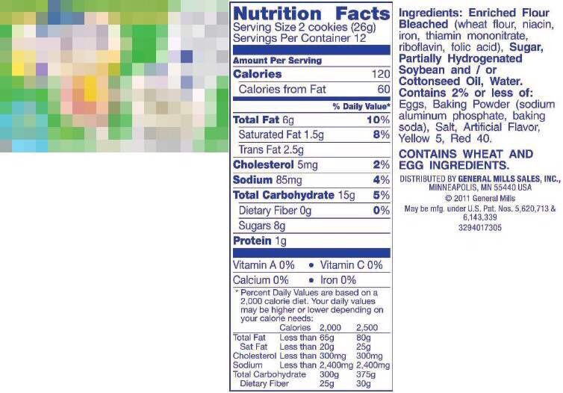

Questions
- If I ate four cookies how many grams of total fat would I consume?

- How many calories would I consume if I ate 2 cookies?

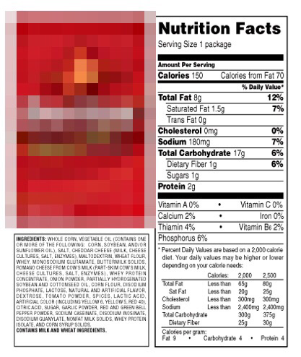
Questions
- If I ate two bags how many grams of total fat would I consume?

- How many calories would I consume if I ate the whole bag?

